Daniel Sung

3.24.23

Development Plans

Happy Dessert Day Factory

1. **Javascript Libraries/Effects/Interactions**
   1. One javascript library that I will use is react.js.
   2. Some effects/widgets that I will be using are the carousel widget for images of the various desserts on the menu from react.js and animations for certain
   3. In addition to these effects, I will be using tooltips so that when hovering over desserts the descriptions or their ingredients can pop up on the side.
   4. jQuery: animations, accordions, tabs
2. Description of these effects
   1. Some effects/widgets that I will be using are the carousel widget for images of the various desserts on the menu from react.js and animations for certain. In the menu section, I will show a slideshow widget that users can interact with to view the different desserts offered at the shop.
   2. In addition to these effects, I will be using tooltips so that when hovering over an image with the mouse the descriptions pop up. For example. For desserts, the descriptions or their ingredients can pop up on the side when hovering over the menu. Another way this could be used is in the contact form. When hovering over certain parts of the contact form a pop-up tells the user more specific information.
   3. Furthermore, I will be using jQuery for simple animations such as fade-in, fadeout, and slide animations. For example, when clicking on the image of a dessert the descriptions of the dessert could fade in and out when clicked on again.
3. How to Reference and Implement
   1. Carousel Widget
      1. 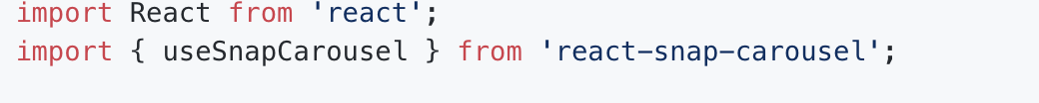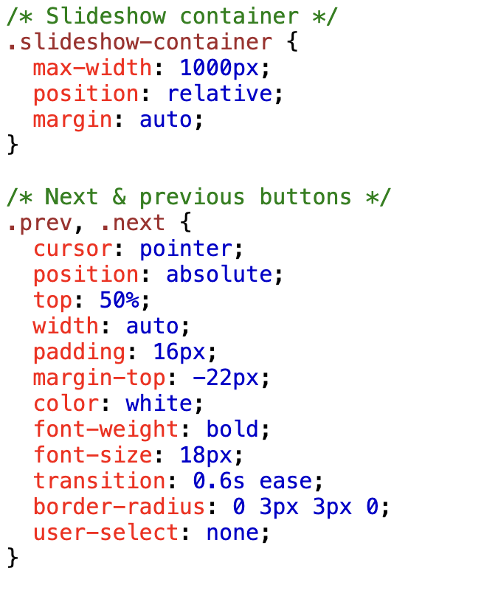
   2. Tooltips Effects
      1. <div class="tooltip">Hover over me
      2. <span class="tooltiptext">Tooltip text</span>
      3. </div>
      4. 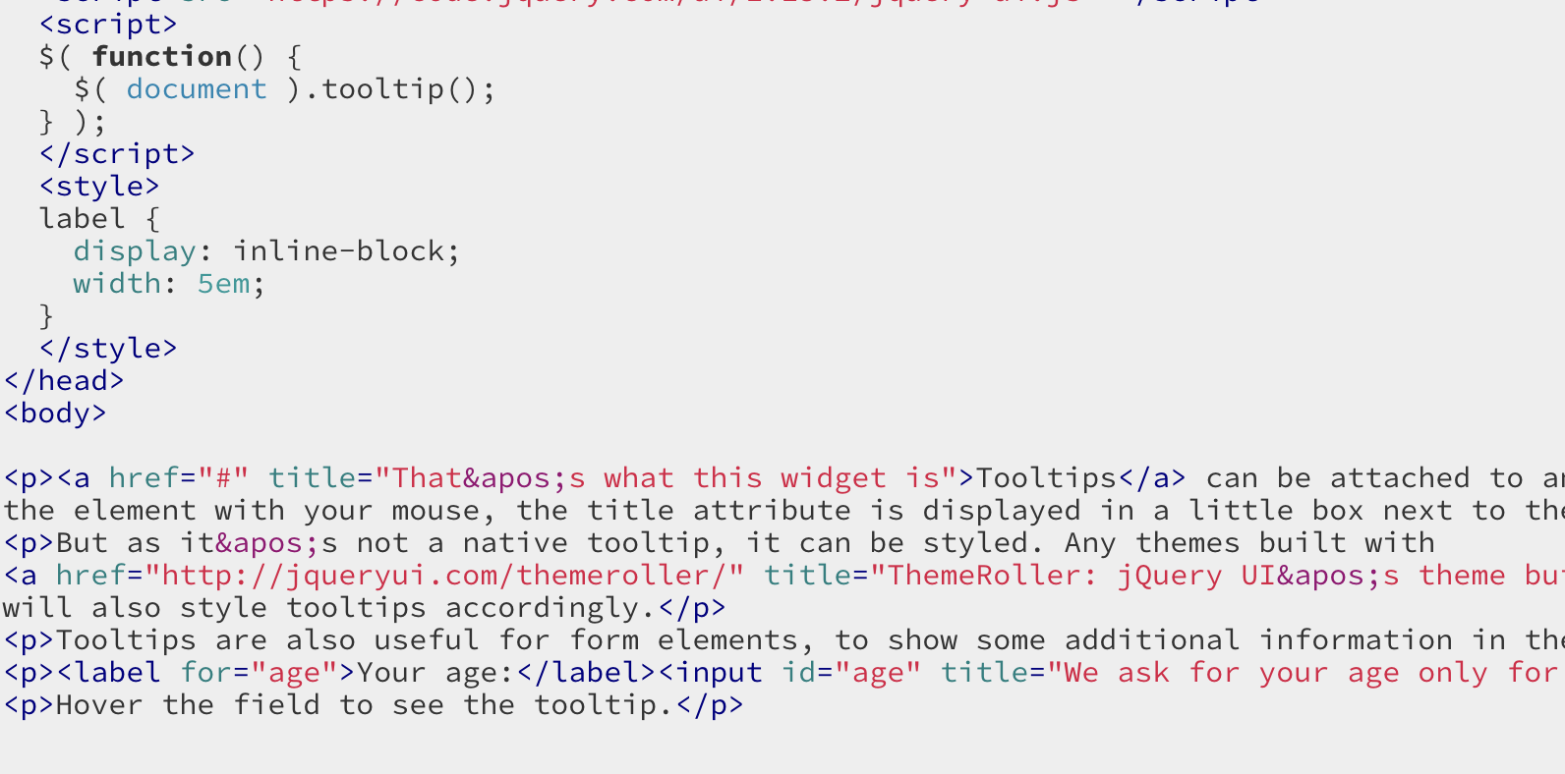
   3. jQuery Animation effects
      1. <script src="<https://ajax.googleapis.com/ajax/libs/jquery/3.6.3/jquery.min.js>"></script>
      2. 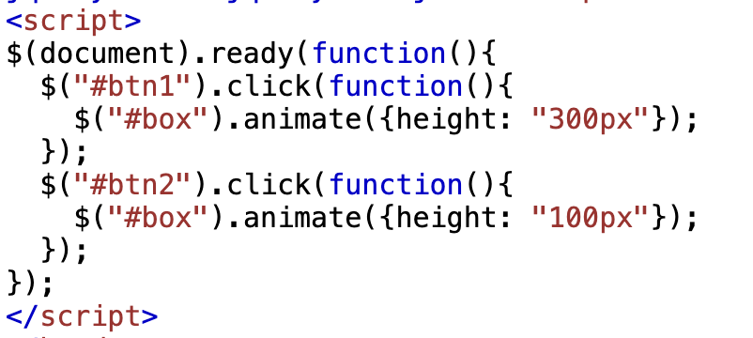
   4. jQuery Accordion Widget
      1. 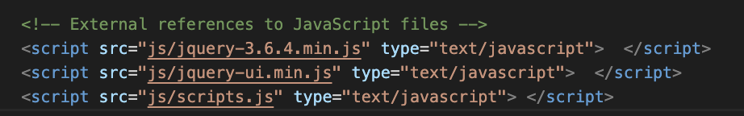
      2. 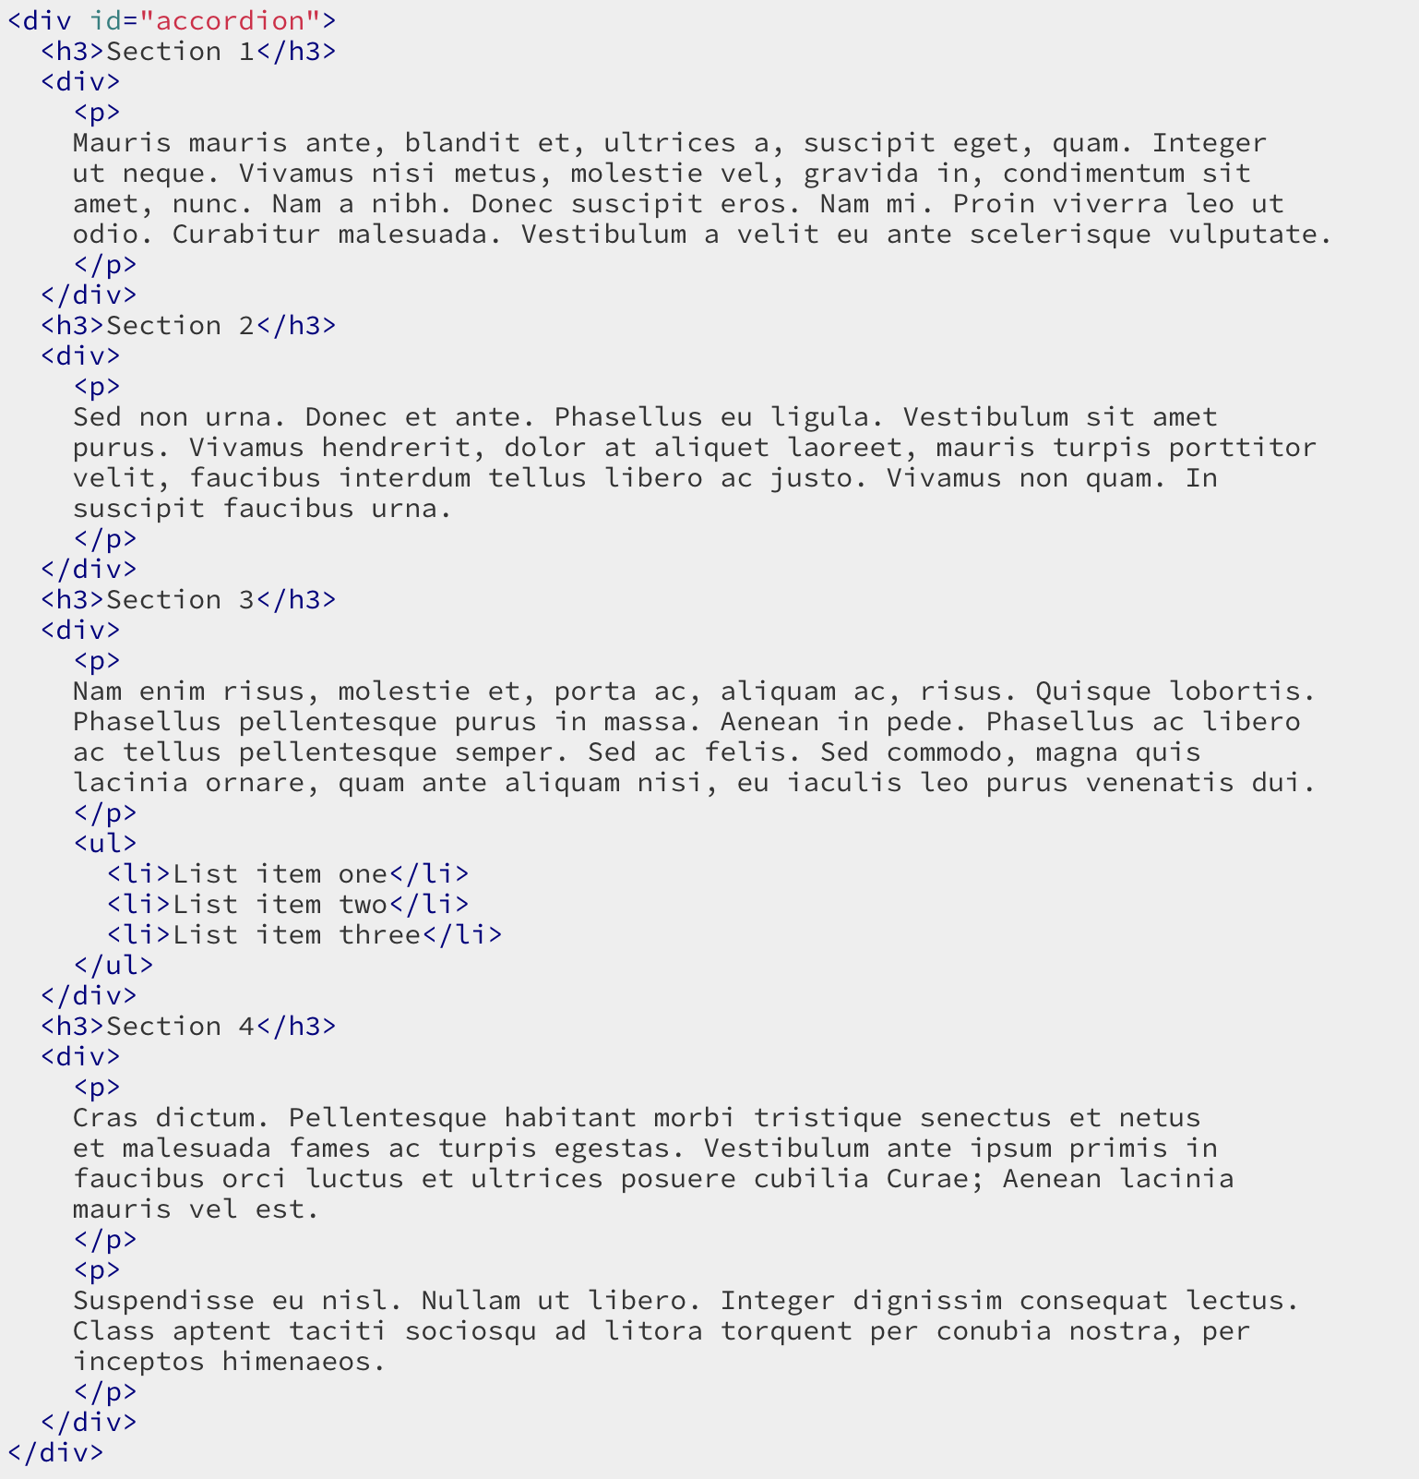
   5. jQuery Tabs
      1. 
      2. 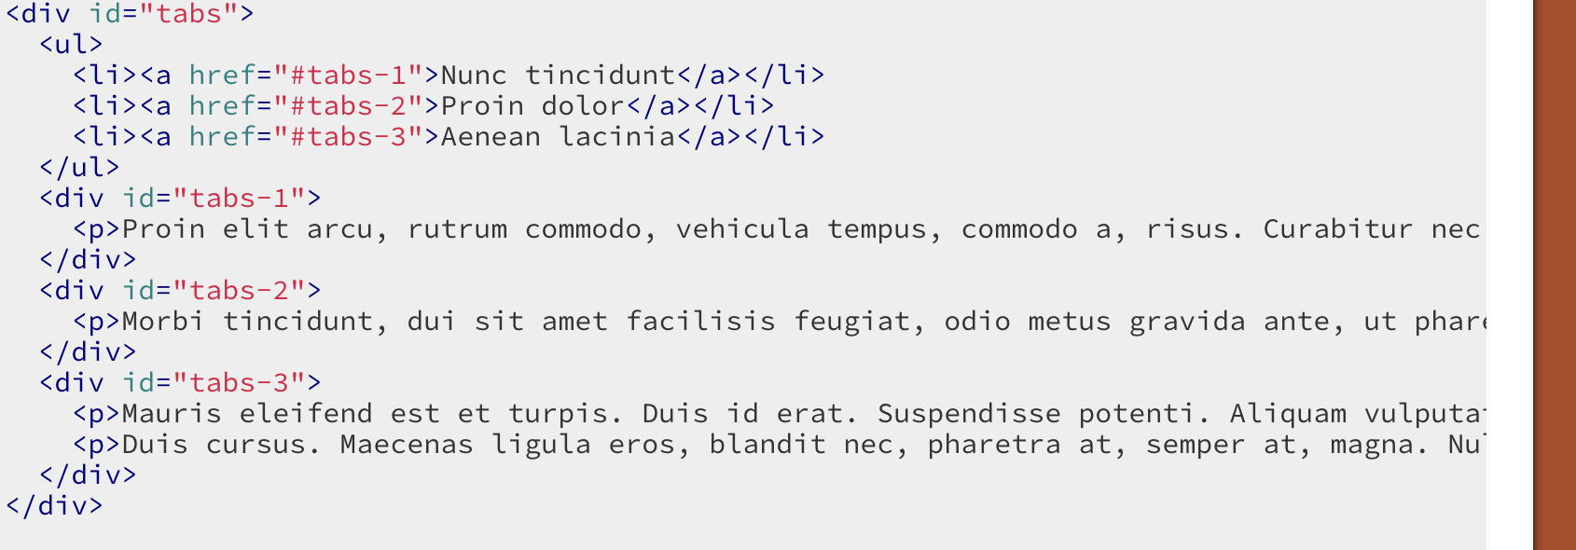
4. Sources
   1. Carousel Widget
      1. <https://www.w3schools.com/howto/tryit.asp?filename=tryhow_js_slideshow>
      2. <https://www.npmjs.com/package/react-responsive-carousel>
      3. <https://reactjsexample.com/react-snap-carousel-dom-first-responsive-carousel-for-react/>
   2. Tooltips Effects
      1. <https://www.w3schools.com/howto/howto_css_tooltip.asp>
      2. <https://jqueryui.com/tooltip/>
   3. jQuery Animation effects
      1. https://www.w3schools.com/jquery/jquery_ref_effects.asp
   4. jQuery Accordion Widget
      1. https://jqueryui.com/accordion/
   5. jQuery Tabs
      1. https://jqueryui.com/tabs/